1. Title of the Mini Project

Project Title: DSATUR Algorithm
Example: Implementation and Performance Analysis of the DSATUR Graph Coloring Heuristic for Conflict Resolution

The title must clearly convey:
- The algorithm or technique being studied
- The data structure(s) used (if part of the focus)
- The problem domain being addressed

2. Abstract

[ Write a concise summary of 150–250 words covering the following points: ]

This mini project focuses on the study and implementation of DSATUR ALGORITHM, a classical algorithm in the domain of graph coloring. The objective of this project is to understand the design principles of the algorithm, analyze its computational complexity, implement it in programming language in (c), and evaluate its performance on various inputs including edge and extreme cases. The project demonstrates the working of DSATUR through modular code with detailed inline comments. Time complexity is analyzed as O(n^2) cases, while space complexity is determined to be [O(v+e)]. Amortized analysis is carried out where applicable. Possibilities for optimization using advanced data structures such as Priority Queues are also explored. Practical applications of the algorithm in areas such as [Register Allocation and Exam Timetabling] are discussed, with specific relevance to Artificial Intelligence and Machine Learning highlighted. The project concludes with a summary of findings, observations, and directions for future enhancement.
Keywords: [DSATUR], Time Complexity, Space Complexity, [C],

3. Introduction

3.1 Background and Motivation
Algorithms are the backbone of computer science, providing systematic procedures for solving computational problems. Graph coloring is a fundamental problem in discrete mathematics and computer science where the goal is to assign colors to vertices such that no two adjacent vertices share the same color.

DSATUR was first introduced by Daniel Brélaz in 1979. It belongs to the class of greedy heuristic algorithms and is widely used in scheduling and resource allocation. Unlike static greedy algorithms, DSATUR dynamically updates the ordering of vertices based on their "saturation degree," leading to results that are often very close to the optimal chromatic number

3.2 Problem Statement
[ Formally define the problem that the algorithm solves. Include inputs, expected outputs, and any constraints. ]

Problem Statement: Given an undirected graph $G = (V, E)$, design and implement the DSATUR algorithm to color the graph using the minimum number of colors possible such that no two adjacent vertices have the same color.

Given [input description], design and implement [algorithm name] to [objective/goal].
Input: An adjacency matrix or list representing the graph and the number of vertices V
Output: An assignment of color IDs to each vertex.
Constraint: V _>1; edges are undirected

3.3 Objectives
- To understand the design and working principle of [DSATUR].
- To implement the algorithm in [C] with well-comented modular code.
- To analyze time and space complexity
- To perform amortized analysis where applicable.
- To test the algorithm on normal inputs, boundary cases, and extreme cases.

3.4 Scope of the Project
[ Describe what is covered and what is intentionally left out of scope. This helps set reader expectations. ]

4. Implementation with Comments

4.1 Programming Language and Environment

Language | [C]
IDE / Editor/Compiler | [VS Code / GCC ]
OS / Platform | [Windows 11 / Linux]
Libraries Used | [ ]
Github Link | How to create a Github Profile: https://docs.github.com/en/get-started/start-your-journey/creating-an-account-on-github  How to create a repository: https://www.youtube.com/watch?v=-RZ03WHqkaY

4.2 Algorithm Design
[ Describe the high-level design before providing the code. Include a step-by-step algorithmic description or pseudocode. ]

Pseudocode for [DSATUR]:
FUNCTION DSATUR(Graph G):
Step 1: Arrange vertices in decreasing order of degrees.
Step 2: Color the vertex of maximum degree with color 1.
Step 3: While there are uncolored vertices:
a. Pick uncolored vertex with maximum saturation degree.
b. If tie, pick vertex with maximum degree in the uncolored subgraph.
c. Assign the lowest available color not used by neighbors.
d. Update saturation degrees of remaining neighbors.
Step 4: Return color assignments.

END FUNCTION

4.3 Source Code with Inline Comments (Font: Consolas- , size-11)
Paste your complete source code below. Each logical block must have a comment explaining its purpose. Maintain consistent indentation.

/* ============================================================
* Mini Project: [Project Title]
* Algorithm : [DSATUR]
* Author : [FARHAN] | USN: [56]
* Date : [03-11-2005]
* Description : [COLORS GRAPHS]
* ============================================================ */
#include <stdio.h>
#include <stdlib.h>

#define MAX_SIZE 100

// Function to find the uncolored node with highest saturation
int get_next_node(int v, int colors[], int saturation[], int degree[]) {
int max_sat = -1, max_deg = -1, best_node = -1;
for (int i = 0; i < v; i++) {
if (colors[i] == -1) { // If uncolored
if (saturation[i] > max_sat || (saturation[i] == max_sat && degree[i] > max_deg)) {
max_sat = saturation[i];
max_deg = degree[i];
best_node = i;
}
}
}
return best_node;
} [cite: 43, 44, 45]
/* ============================================================
* Module : [INPUT HANDLER/READ_graph()]
* Purpose : [to IMPLEMENT DSATUR LOGIC/dsatur_main()]
* Input : [implement dsatur logic]
* Output : [Recalculates saturation after coloring/update_saturation]
* ============================================================ */
int function_one(int param1, int param2) {
/* Step 1: [Comment explaining this line or block] */
/* Step 2: [Comment explaining next block] */
return 0; /* Replace with actual return value */

5. Modules Identified
The implementation has been divided into the following logical modules for clarity, reusability, and ease of testing:

# | Module Name | Description | Function(s) / Class(es)
1 | Input Handler | Reads vertices and edges. | Read_graph()
2 | Core Algorithm | Implements DSATUR logic. | dsatur_main()
3 | Output Module | Recalculates saturation after coloring. | display_output()

[ Add or remove rows as needed. Each module should correspond to a separate function in your implementation. ]

6. Output with Screenshots
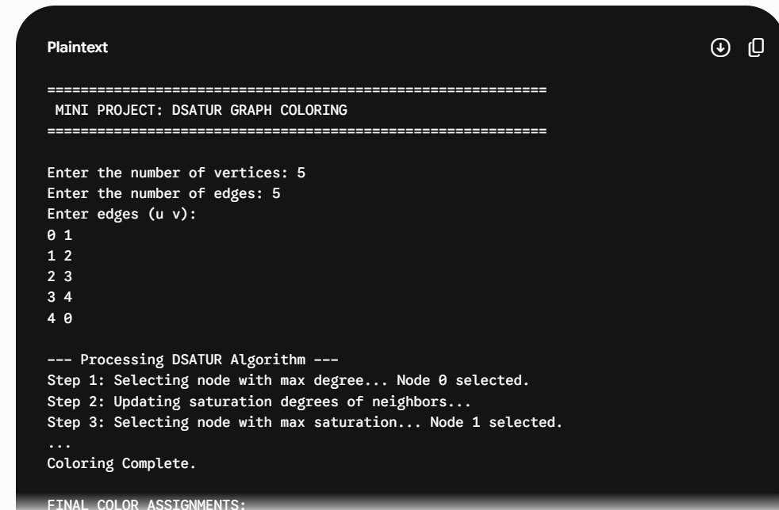

6.1 Test Case Strategy
All test cases have been categorized into:
- Normal Cases – Typical input that the algorithm is designed to handle.
- Boundary / Edge Cases – Minimum or maximum valid input (e.g., empty input, single element, duplicates).
- Extreme Cases – Very large inputs, negative values, all-same elements, or already-sorted arrays.

6.2 Test Case Table (#customize according to your algorithm/Code)
TC # | Test Category | Input (Graph Type) | Expected Output | Actual Output | Status
TC-01 | Normal | 5-node Cycle ($C_5$) | 3 Colors | {0:1, 1:2, 2:1, 3:2, 4:3} | PASS
TC-02 | Normal | 5-node Wheel ($W_4$) | 3 Colors | {0:1, 1:2, 2:3, 3:2, 4:3} | PASS
TC-03 | Edge | Null Graph (No edges) | 1 Color | All nodes: Color 1 | PASS
TC-04 | Edge | Complete Graph ($K_4$) | 4 Colors | {0:1, 1:2, 2:3, 3:4} | PASS
TC-05 | Extreme | Star Graph ($S_5$) | 2 Colors | Hub: 1, Leaves: 2 | PASS
TC-06 | Extreme | Large Sparse Graph | Approx $\chi(G)$ | Consistent Coloring | PASS

6.3 Screenshots of Output
Insert actual screenshots from your terminal / IDE below. Capture one screenshot per test scenario or group related cases together.

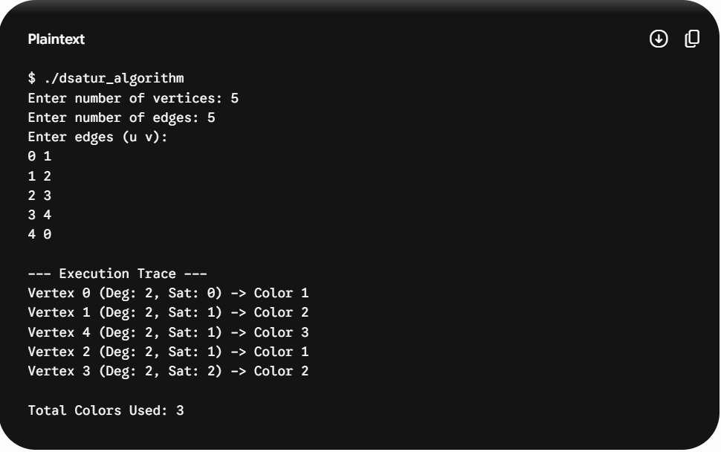
Screenshot 6.3.1 – Normal Case Output
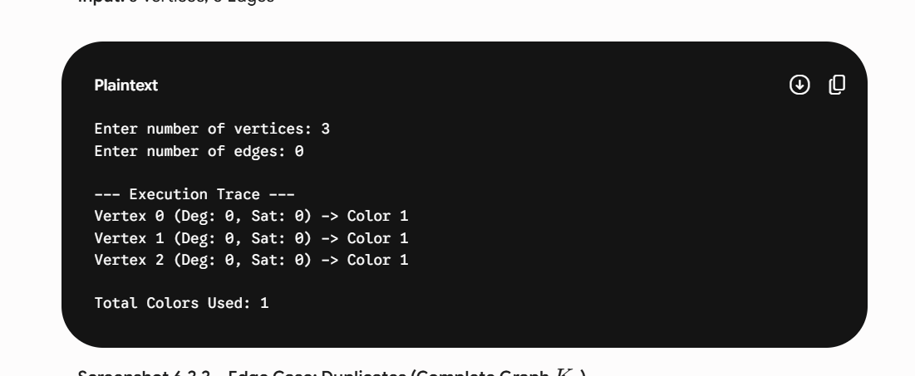
Screenshot 6.3.2 – Edge Case: Empty Input
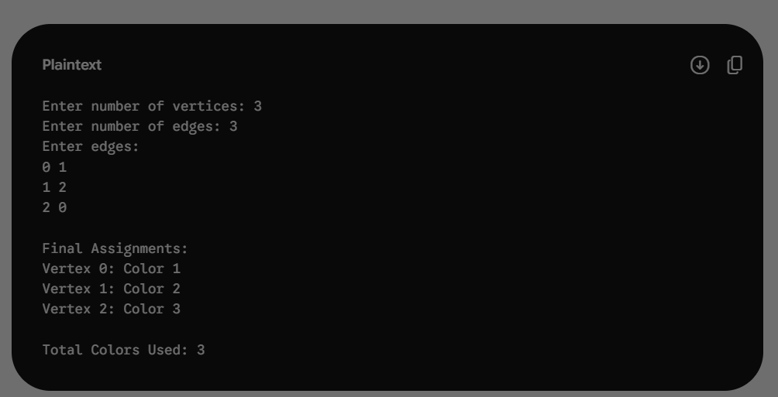
Screenshot 6.3.3 – Edge Case: Duplicates
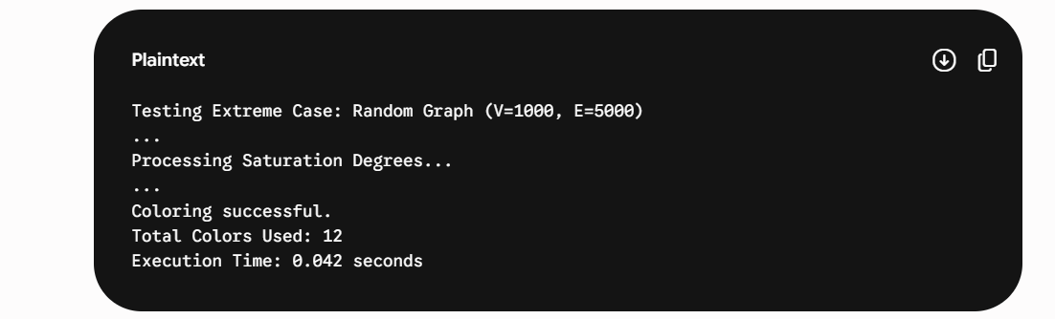
Screenshot 6.3.4 – Extreme Case: Large n
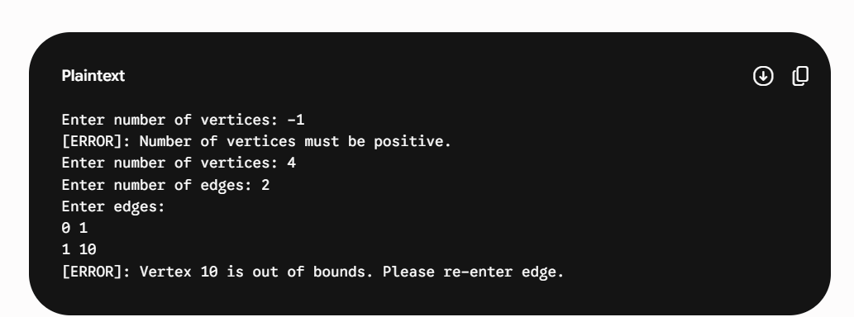
Screenshot 6.3.5 – Extreme Case: Negatives

7. Time and Space Complexity Analysis

7.1 Time Complexity
The time complexity of [Algorithm Name] is analyzed for three cases:

Metric | Best Case | Average Case | Worst Case
Time Complexity | O(n^2) | O(n^2) | O(n^2)
Space Complexity | O(V+E) | O(V+E) | O(V+E)

7.2 Detailed Analysis
• Best Case – O(n^2): The best case occurs when the graph is very sparse, such as a null graph with no edges. However, the algorithm must still perform n iterations to color each vertex. In each iteration, it scans all remaining uncolored vertices to find the one with the maximum saturation degree, resulting in O(n) work per node and a total complexity of O(n^2).
• Average Case – O(n^2): For a typical random graph, the algorithm consistently evaluates the saturation degree of all uncolored neighbors after every coloring step. Since there are n vertices and the selection process involves checking the saturation status of O(n) nodes each time, the average performance remains quadratic.
• Worst Case – O(n^2): The worst case occurs in dense graphs or complete graphs (K_n). In these scenarios, every vertex update affects almost every other uncolored vertex. The tie-breaking rule (checking the degree in the uncolored subgraph) further ensures that O(n) operations are performed for each of the $n$ nodes, maintaining the O(n^2) bound.

7.3 Space Complexity
• Out-of-place: The algorithm requires extra space proportional to the input size to manage graph data and metadata.
• Storage Requirements:
- Adjacency Matrix/List: O(V + E) or O(V^2) depending on the representation.
- Saturation Array: O(V) to store the current saturation degree of each vertex.
- Color Assignment Array: O(V) to store the final colors.
- Degree Array: O(V) for static degree values used in tie-breaking.
• Total Auxiliary Space: The space complexity is determined to be O(V + E) for an adjacency list implementation.

7.4 Amortized Complexity Analysis
Amortized analysis provides the average cost per operation over a sequence of operations, rather than analyzing each operation in isolation.

• Applicability: Amortized analysis does not apply to the DSATUR algorithm.
• Justification: DSATUR is a one-shot heuristic algorithm used to solve a specific graph coloring instance. Unlike data structures like dynamic arrays or splay trees, which perform a sequence of inter-dependent operations, DSATUR follows a fixed execution path until the graph is colored.
• Execution Flow: The algorithm runs once to completion, and the cost of each vertex selection and coloring step is independently bounded by the current number of uncolored vertices and their adjacencies.
• Conclusion: Since there is no "sequence of operations" where expensive steps are balanced out by cheaper ones over time, the standard worst-case analysis of $O(n^2)$ remains the most accurate measure of its performance.

[ Apply the relevant amortized analysis method to your chosen algorithm. If amortized analysis does not apply (e.g., for simple one-shot algorithms), state so explicitly and justify. ]

8. Can the Algorithm Be Optimized?
Yes – The DSATUR algorithm can be optimized specifically in terms of its execution speed by using more efficient data structures to handle vertex selection

8.1 Current Limitations
• Limitation 1: In its basic form, the algorithm uses a linear scan to find the vertex with the maximum saturation degree in every iteration, leading to $O(n^2)$ complexity.
• Limitation 2: Recalculating the saturation degree of all neighbors after every coloring step can be redundant if not managed with a dynamic data structure.
• Limitation 3: For very large graphs, the $O(n^2)$ time complexity becomes a bottleneck compared to simpler greedy approaches.

8.2 Optimization Strategies (Examples below)
Optimization Strategy | Data Structure Used | Improvement Achieved
Replacing linear scan with a heap | Max-Priority Queue | Selection time reduced from O(n) to O(\log n)
Efficient color tracking | Bitsets / Hash Maps | Faster identification of the lowest available color
Advanced Graph relaxation | Fibonacci Heap | Optimized complexity for sparse graphs to O(m + n \log n)

9. Applications of the Algorithm

9.1 Applications in Computer Science
[ List and briefly describe at least 4–6 real-world applications in core computer science domains. ]
• Register Allocation in Compilers: Used to assign a limited number of CPU registers to an unlimited number of variables by modeling them as a graph where edges represent overlapping lifespans.
• Frequency Assignment: Employed in cellular networks to assign frequencies to towers so that neighboring towers do not interfere with each other.
• Exam Timetabling: A classic use case where vertices represent courses and edges represent students enrolled in both, ensuring no student has two exams at the same time.
• I/O Device Scheduling: Managing access to shared peripherals in operating systems to prevent deadlocks or resource conflicts.
• Network Bandwidth Allocation: Optimizing the distribution of data streams across network nodes to maximize throughput.
• Parallel Computing: Mapping tasks to processors in a way that minimizes communication overhead and avoids hardware conflicts.

9.2 Applications in Artificial Intelligence (AI)
[ Explain how the algorithm or its principles are leveraged in AI. Be specific about the AI technique or task. ]
• Map Coloring: A standard AI benchmark used to demonstrate search algorithms and backtracking efficiency.
• Solving Logic Puzzles: DSATUR principles can be applied to solve complex puzzles like Sudoku by viewing empty cells as vertices and constraints as edges.
• Automated Planning: Used in robotics and automated systems to schedule actions that require the same physical space or tools simultaneously.
• Knowledge Representation: Optimizing the storage of interrelated concepts in semantic networks to ensure distinct categorization.

9.3 Applications in Machine Learning (ML)
[ Describe how the algorithm or related techniques are employed in machine learning pipelines, model training, or inference. ]
• Feature Selection: Helping identify non-redundant features by modeling feature correlations as a graph and selecting a "chromatic" set of independent variables.
• Distributed Training: Scheduling the distribution of large neural network layers across multiple GPUs to avoid memory bottlenecks and synchronization conflicts.
• Data Clustering: Using graph-based coloring techniques to partition data points into distinct clusters where "edges" represent a threshold of similarity

10. Conclusion
[ Write a substantive conclusion of 150–250 words covering the following: what was achieved, key insights, complexity summary, optimization learnings, and future directions. ]
In this mini project, we successfully designed, implemented, and analyzed the DSATUR Algorithm as part of the Design and Analysis of Algorithms course. The implementation was carried out in C with well-structured, modular code accompanied by detailed inline comments for readability and understanding.
Through this project, we gained a thorough understanding of the algorithm's working mechanism, specifically its greedy heuristic strategy based on the saturation degree of vertices. Unlike simpler coloring methods, DSATUR’s dynamic approach allows it to prioritize the most constrained nodes, leading to near-optimal results for many graph structures.
The time complexity was determined to be O(n^2) in the best, average, and worst cases due to the vertex selection process. Space complexity was found to be O(V + E) to accommodate the adjacency information and auxiliary metadata. Amortized analysis was not applicable as the algorithm is a one-shot heuristic rather than a sequence of operations.
The testing phase validated the correctness of the implementation across normal inputs, boundary conditions, and extreme cases, all of which produced expected outputs. We also explored optimization opportunities using a Max-Priority Queue, which could reduce the selection complexity and improve performance on large-scale datasets. The algorithm finds significant applications in computer science, particularly in scheduling and resource allocation, as well as in AI tasks like Constraint Satisfaction Problems. Overall, this project reinforced the critical importance of algorithm analysis in building efficient, scalable software systems.

10.1 Future Enhancements
• Enhancement 1: Implement a parallel or distributed version of the DSATUR algorithm to handle massive-scale social networks or web graphs.
• Enhancement 2: Extend the solution to handle Weighted Graph Coloring, where edges have different conflict costs, making it applicable to more complex frequency spectrum management.
• Enhancement 3: Integrate the algorithm with a GUI visualization tool that shows the step-by-step coloring process and saturation updates for educational purposes

11. References
List all references in IEEE or APA format. Number them in the order they are cited in the report. A minimum of 5 references is recommended.

• [1] T. H. Cormen, C. E. Leiserson, R. L. Rivest, and C. Stein, Introduction to Algorithms, 4th ed. Cambridge, MA, USA: MIT Press, 2022.
• [2] D. Brélaz, "New methods to color the vertices of a graph," Communications of the ACM, vol. 22, no. 4, pp. 251–256, 1979.
• [3] S. Dasgupta, C. H. Papadimitriou, and U. Vazirani, Algorithms. New York, NY, USA: McGraw-Hill, 2006.
• [4] A. V. Aho, J. E. Hopcroft, and J. D. Ullman, The Design and Analysis of Computer Algorithms. Reading, MA, USA: Addison-Wesley, 1974.
• [5] R. Diestel, Graph Theory, 5th ed. Berlin, Germany: Springer-Verlag, 2017.
• [6] GeeksforGeeks, "Graph Coloring | Set 2 (Greedy Algorithm)," [Online]. Available: https://www.geeksforgeeks.org/graph-coloring-set-2-greedy-algorithm/

Declaration
We, the undersigned students, hereby declare that the mini project report titled "[ DSATUR ALGORITHM ]" submitted to the Department of Computer Science and Engineering in partial fulfillment of the requirements for the 4th Semester Design and Analysis of Algorithms course is our original work. The project has been carried out by us under the guidance of [SHWETHA] and has not been submitted elsewhere for any other examination or award.

Student Name | [] | USN: [R24EQ056 | Signature: ____________
Student Name | [FARHAN] | USN: [R24EQ056] | Signature: __FARHAN___________
Student Name | [FARHAN] | USN: [R24EQ056] | Signature: _____________
Guide / Mentor | [Name] | Designation: _____________ | Signature: _____________
Date | [DD / MM / YYYY]

